Matapeake Middle School
Instructional Lesson Plan

Teacher: Quick | Date: 11/27/2023
Subject: Science | Unit: Energy
Lesson Topic: Energy in Light | Grade: 8th Class Size: 28

Learning Outcomes/Goals/Objectives

Long Term Unit Goal/Objective/Outcome:
- Explore phenomena related to energy-efficiency, such as the example above (in intro) involving light bulbs
- Plan and carry our investigations, and analyze data to figure out how energy is transferred and transformed
- Engage in engineering challenges to design and test devices to maximize and minimize energy transfer
- Investigate the issue of energy-efficiency and energy use

Maryland Common Core Standards/Curriculum Standard(s):
MS-PS3-3
MS-PS3-4

Student Learning Outcome(s)/Objective(s):

Objective: Students will be able to determine if energy is being transmitted, reflected or absorbed in a material by completing a lab investigation that transforms light energy to thermal energy.

Essential Question: What properties of matter affect how it interacts with solar energy?

Context for Learning/ Accommodations/Modifications

Accommodation/modification cheat sheet for all students is found in Mrs. Quick’s files
Modeling proper lab safety and techniques
End of class check-in’s / class review of data
Assistance and check-ins provided by special educator in certain classes
Strategic grouping

UDL:
CheckPoint 3.2: Highlight patterns, critical features, big ideas, and relationships
CheckPoints 5.3: Build fluencies with graduated levels of support for practice and performance
Checkpoint 8.3: Foster Collaboration and community

Instructional Delivery & Assessment

Opening Activities/Motivation/Engagement:
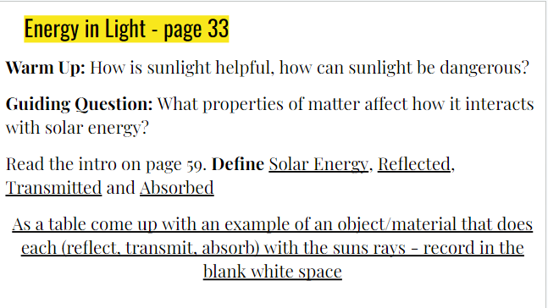

Procedures:

Review lab video with students before going outside so they have an understanding of what the set up should look like.
Review outdoor expectations and lab safety with students.
Have students carry bins of materials outside and set up on the sidewalk.
Students work through procedure set and collect data in notebooks
Clean up materials and come back inside.
Review data as a class - look for patterns and outliers

Assessment:

Class Review of Data Collected
Analysis 1 & 3
- What patterns did you see in the results, and what is the causal relationship for these patterns?
3. Why might it make sense for buildings to have a dark-colored roof in cold climates and a light-colored roof in hot climates? Explain using evidence from this activity.

Closure:

Students complete Analysis 1&3 discuss answers and turn in.

